**PELLET DISPENSER.**

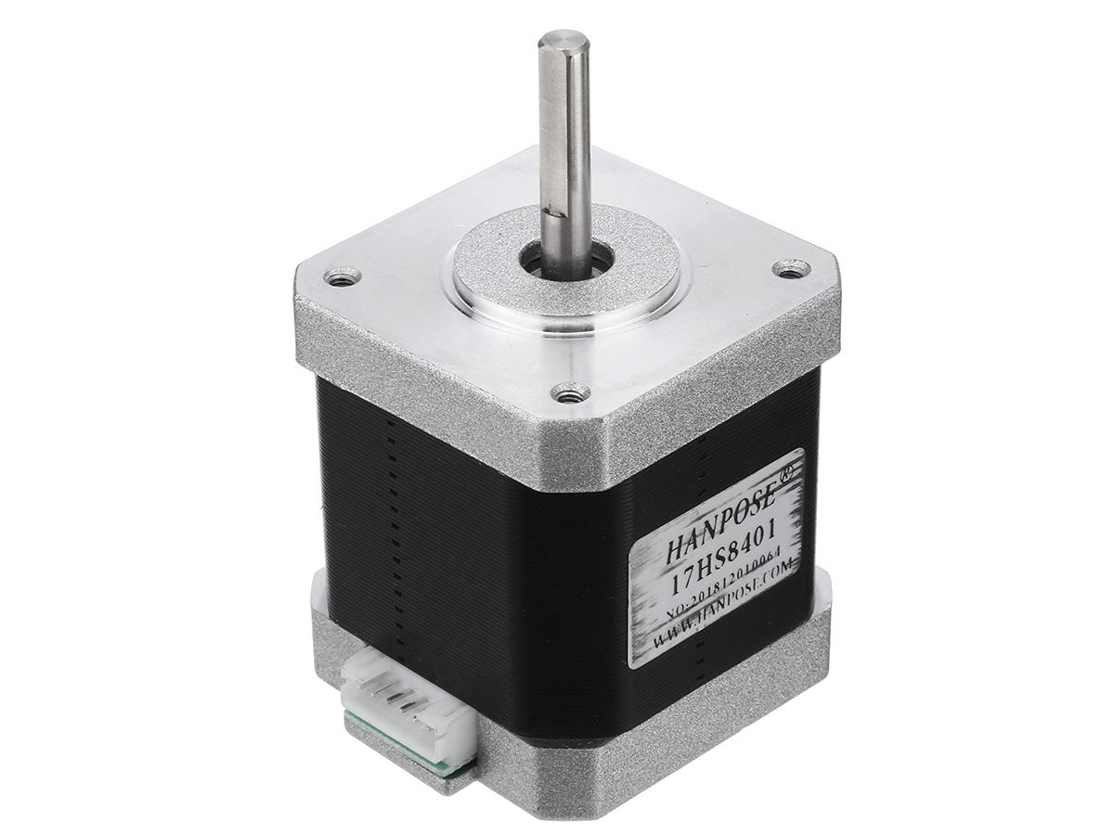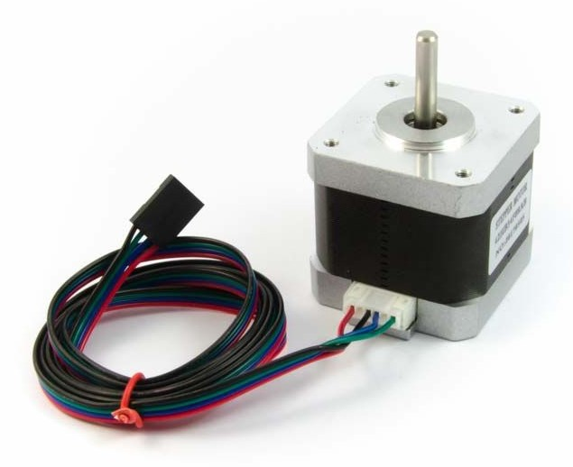The reference of the nema 17 stepper motors used is: **H2HB34F08AB**. Importantly it has a notch in the axis.

This pellet dispenser was used with **20 mg** Dustless Precision Pellets® Rodent (Bio-Serv).

In order to mount it, you will need 2 3mm screws and 1 no-cap 2mm screw.

There are some 3D printed pieces and some laser-cut acrylic pieces. The acrylic pieces are used to smooth the friction between the pellets and the parts, friction that slowly destroys the pellets and forms dust that eventually might stop the pellet-dispenser well-functioning.

**MOUNTING STEPS:**

Unscrew the motor stepper motor screws from the bottom part.

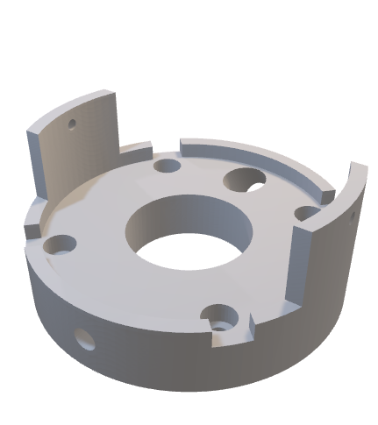Put **pellet dispenser base** 3D piece on top of the motor and screw it with the 4 screws that were removed previously. Notice that this piece has different holes. 2 holes to screw the **pellets holder cylinder**, one big hole for the pellet to fall and another hole that crosses through the piece which is used to tight the wheel to the axis of the motor.

Holes to screw **pellets holder cylinder**

Hole for dropping pellet. Should be aligned with the **pellet dispenser base top** hole and with the **pellets holder cylinder** tear-like piece.

Hole to tight the **wheel** holder piece to the **motor axis**

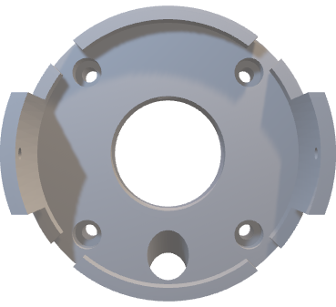Put the 3mm acrylic **pellet dispenser base top** piece on top of it, fitting the notches.

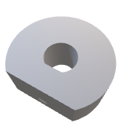Glue the 2mm acrylic **wheel** piece with the **wheel-motoraxis holder** piece, keeping the notch aligned of both pieces.

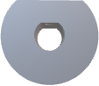

Once glued, put the wheel with the part of the **wheel-motoraxis holder** facing bottom towards the motor and the wheel facing up, through the motor axis, which has a notch same as this piece. The little hole on the pellet dispenser base can be used to tight the wheel to the axis with a non-cap 2mm screw.   
Importantly, the **wheel** piece should have a distance with the **pellet dispenser base top acrylic** piece of about 1 mm.

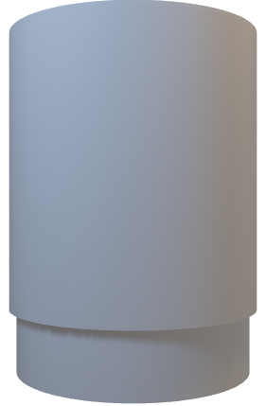Screw the **pellets holder cylinder** to the **pellet dispenser base** with 2 3mm screws. Keep the little tear-like piece of the pellets holder cylinder facing on top of the big hole of the pellet dispenser base.



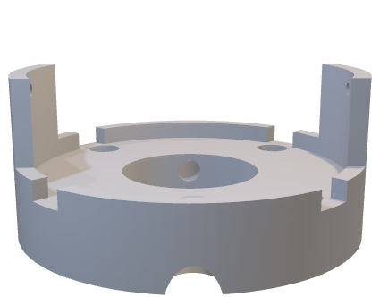

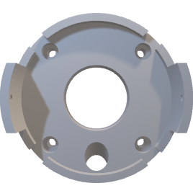

Note that, the **pellets holder cylinder** is 3D printed, but I used 5cm diameter transparent acrylic cylinder, which allows to see the pellets and is useful to check if they get stuck.

Finally, put a silicon tube (0.8cm diameter) of the desired length fitting the hole in the **pellet dispenser base** until touching the **pellet dispenser base top acrylic** piece from the bottom. You might need to cut the tip of the tube to be flat.

